February 2024 - Present

Justin Ilao

Justinilao@hotmail.com

<https://github.com/justinilao>

<https://www.linkedin.com/in/ilaojustin/>

Homelab Documentation

By: Justin Ilao

Table of Contents

I: Topology

II: Proxmox

III: Virtual Machines

IV: Projects

Topology

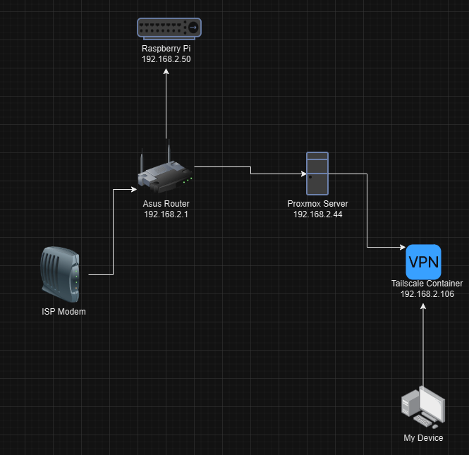

Proxmox

Old Gaming PC wiped and configured with Proxmox

Specs:

Cpu:

AMD R5 2500X

Graphics Card:

GTX 1050 TI

Ram:

12GB DDR4 Memory

Storage:

1TB SSD

Notes:

- Plans to upgrade soon.

Virtual Machines

Overview:

Several virtual machines and containers have been deployed to simulate an internal enterprise network environment, including a domain controller and an active web server for pentesting purposes.

**Windows Server:**

- Installed Windows Server 2016.

- Hardware and options setup:

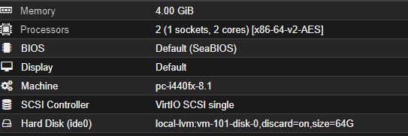

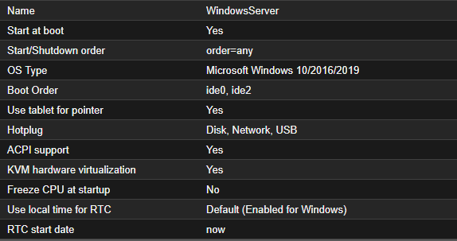

- Added active directory domain service and promoted this server as a domain controller,

adding windowsserver.local as the domain name.

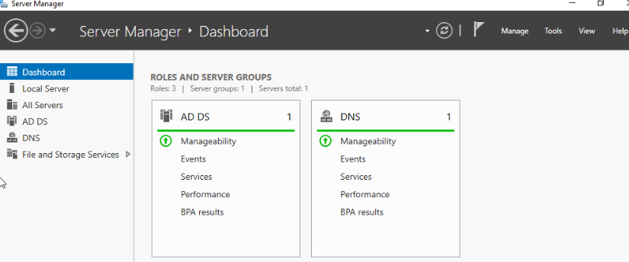

**Pfsense:**

- Installed and deployed a Pfsense vm on the Proxmox server.

- Configured the correct lan and wan interfaces.

- Had the router on the 192.168.2.0/24 subnet, leasing ip’s through DHCP to all vms on the Proxmox server.

-Virtual Machine is now out of use.

**Ubuntu Server:**

- Installed and configured Ubuntu Server.

**-** Installed nginx, mysql and php to create an application server.

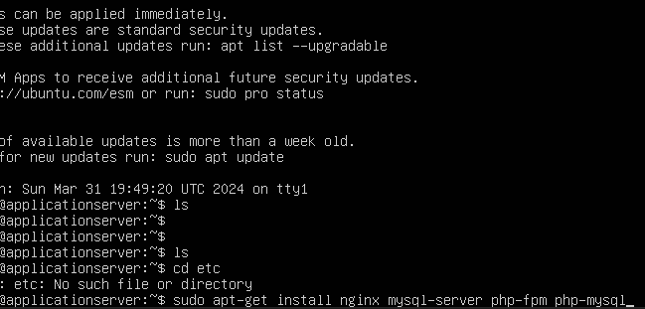

- Navigated to sites-enabled directory.



- Commented out necessary lines to enable php.

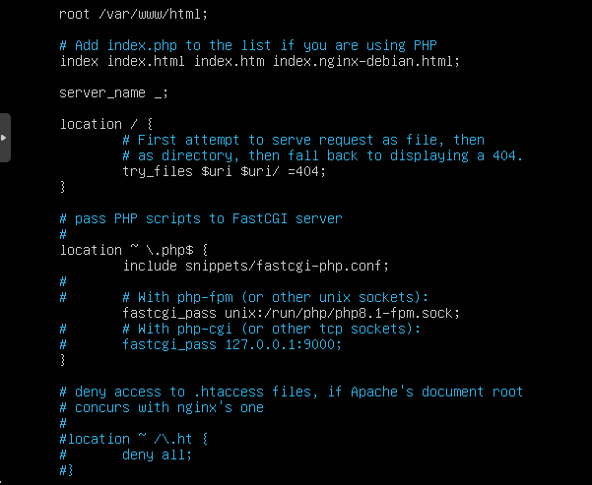

**Windows Web Server:**

- Installed Windows Server 2016

- Added Web Server(IIS) server role.

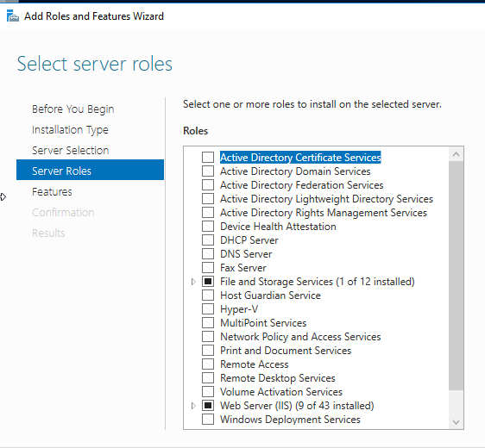

- Joined the web server to the domain.

**Kali Linux:**

- Setup Kali Linux to be used as a pen testing machine.

- Installed Nessus.

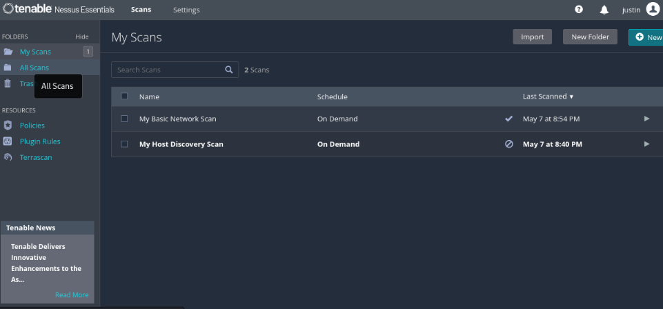

- Used tools such as nmap, Metasploit, aircrack ng, and others to exploit the Windows Server machine as well as the website running on the Ubuntu Server/Windows Web Server

**Windows Machines:**

- Created 2 basic Windows 10 machines

- Joined them to the domain.

Projects

Completed:

* Deploy virtual machines to learn the in’s and out’s of Proxmox: Finished 2024-04-5
* Convert pfsense router into asus router: Finished 2024-05-11
* Access homelab outside of lan through <https://tailscale.com/>: Finished 2024-05-11

In Progress:

* Implement SIEM: In Progress
* Implement Raspberry Pi: In Progress